Table of Contents
More Information About Skorch 1
Linear Regression Model 2
Grid and Random Searching Linear Regressions 5
Skorch for Handwriting Classification 8

More Information About Skorch
A fair amount of information for this section about skorch is taken from:
https://skorch.readthedocs.io/en/stable/user/neuralnet.html

NeuralNet and the derived classes enable skorch. These classes wrap a custom PyTorch Module while providing an interface that is familiar for sklearn users. In particular, the interface allows us to use GridSearchCV and RandomizedSearchCV. Last day NeuralNetClassifier from skorch was used. Today, NeuralNetRegressor from skorch will be used.

Once the PyTorch Module is defined, it can then be passed to NeuralNet, in conjunction with a PyTorch criterion. Finally, you can call fit() and predict(), as with an sklearn estimator. The finished code could look something like this:
class MyModule(torch.nn.Module):
...

net = NeuralNet(
module=MyModule,
criterion=torch.nn.NLLLoss,
)
net.fit(X, y)
y_pred = net.predict(X_valid)

skorch:

- wraps the PyTorch Module in an sklearn interface
- converts numpy.ndarrays to PyTorch Tensors if necessary
- abstracts away the fit loop
- takes care of batching the data

You therefore have a lot less boilerplate code, letting you focus on what matters. At the same time, skorch is very flexible and can be extended with ease.

Linear Regression Model
Example 1: Linear Regression
This example demonstrates how to create a neural network in PyTorch for linear regression with
skorch. The detail for how the PyTorch code works is in the comments. Exercises later will offer hands-on practice for a better understanding

The model gives quite different results from one run to the next. Part of the problem is that there is not much data so each training session uses a very different subset of data when the data is randomized.

RMSE: 43.60546 | RMSE: 88.813866 | RMSE: 32.51236
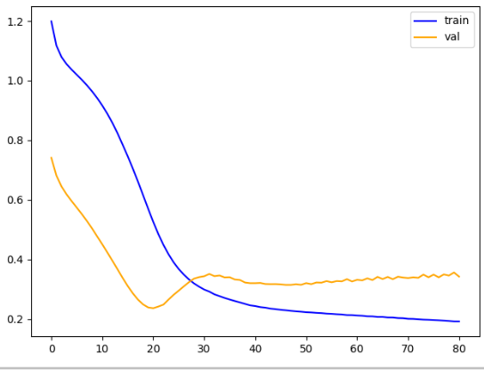 | 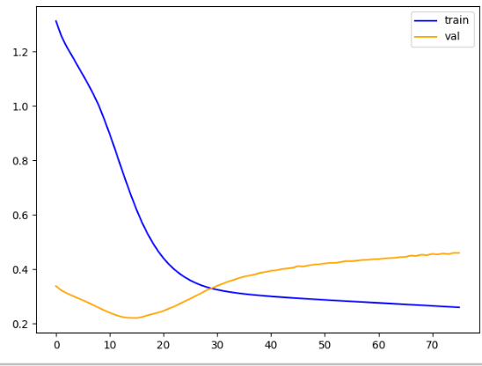 | 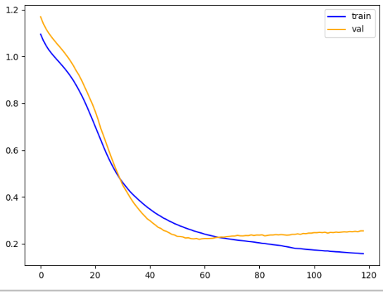

Notice that the networks parameter dictionary is passed to the object during instantiation with the **params parameter. The forward() function the network receives the dictionary with the **kwargs parameter.
Here is the code:
from sklearn.datasets import make_regression
from skorch import NeuralNetRegressor
import torch.nn as nn
import numpy as np
from sklearn.model_selection import train_test_split
from sklearn.metrics import mean_squared_error
import torch.nn.functional as F
from torch import optim

# This class could be any name.
# nn.Module is needed to enable grid searching of parameters
# with skorch later.
from skorch.callbacks import EarlyStopping

class MyNeuralNet(nn.Module):
def __init__(self, num_units=10, nonlin=F.relu):
super(MyNeuralNet, self).__init__()
self.num_units = num_units
self.nonlin = nonlin

self.dense0 = nn.Linear(4, num_units) # Create layer. Set # inputs/outputs.
self.nonlin = nonlin
self.dense1 = nn.Linear(num_units, 10)
self.output = nn.Linear(10, 1)

def forward(self, X, **kwargs):
X = self.nonlin(self.dense0(X))
X = F.relu(self.dense1(X))
X = self.output(X)
return X

def buildModel(x, y):
# Trains the Neural Network with fixed hyperparameters
# The Neural Net is initialized with fixed hyperparameters
myNetwork = MyNeuralNet(num_units=10)

# Define learning rate, max_epochs and momentum
# separately from the network.
params = {
'lr': 0.001, # Learning rate
'max_epochs': 1000, # Maximum number of epochs
'optimizer':optim.SGD,
'optimizer__momentum': 0.9, # Standard default. Range is 0 to 1.
}

net_regr = NeuralNetRegressor(
myNetwork,
**params,
callbacks=[EarlyStopping(patience=60)],
)
model = net_regr.fit(x, y)
return model

def evaluateModel(model, X_test, y_test, scalerY):
print(model)
y_pred_scaled = model.predict(X_test)
y_pred = scalerY.inverse_transform(y_pred_scaled)
mse = mean_squared_error(y_test, y_pred)
rmse = np.sqrt(mse)
print("RMSE: " + str(rmse))

# Prep the data.
# This is a toy dataset for regression, 1000 data points with 20 features each
import torch
import pandas as pd
df = pd.read_csv('/users/pm/desktop/daydocs/data/petrol_consumption.csv')
X = df.copy()
del X['Petrol_Consumption']
y = df['Petrol_Consumption']

X_train, X_test, y_train, y_test =\
train_test_split(X, y, test_size=0.2)

from sklearn.preprocessing import StandardScaler
scalerX = StandardScaler()
scaledXTrain = scalerX.fit_transform(X_train)
scaledXTest = scalerX.transform(X_test)

scalerY = StandardScaler()
scaledYTrain = scalerY.fit_transform(np.array(y_train).reshape(-1,1))

# Must convert the data to PyTorch tensors
X_train_tensor = torch.tensor(scaledXTrain, dtype=torch.float32)
X_test_tensor = torch.tensor(scaledXTest, dtype=torch.float32)
y_train_tensor = torch.tensor(list(scaledYTrain), dtype=torch.float32)
y_test_tensor = torch.tensor(list(y_test), dtype=torch.float32)

# Build the model.
model = buildModel(X_train_tensor, y_train_tensor)
print(model.get_params())

# Evaluate the model.
evaluateModel(model, X_test_tensor, y_test_tensor, scalerY)

import matplotlib.pyplot as plt
def drawLossPlot(net):
plt.plot(net.history[:, 'train_loss'], color='blue', label='train')
plt.plot(net.history[:, 'valid_loss'], color='orange', label='val')
plt.legend()
plt.show()
drawLossPlot(model)

Exercise 1 (1 mark)
What does the num_units parameter represent in the MyNeuralNet constructor?

Exercise 2 (1 mark)
Describe the architecture of this neural network in Example 1. How many layers does it have? What are the types of layers? What are the input and output dimensions?

Exercise 3 (1 mark)
What activation function is used in this network in Example 1?

Exercise 4 (1 mark)
What does nn.Linear represent?

Exercise 5 (1 mark)
What happens during a forward pass in Example 1?

Exercise 6 (4 marks)
Create an additional hidden layer for the network in Example 1.
Show a screenshot of your model which displays the different layers of the network. However include your name and be sure that there is an extra later in the network.
Show your screenshot here:

Exercise 7 (4 marks)
Use the USA_Housing.csv data set to build a PyTorch network with to predict Price. Use all available features except ‘Address’. Show your loss curve and RMSE here.
Show the code as text for your complete program here:

Grid and Random Searching Linear Regressions
To obtain an optimal parameter set, a series of parameter ranges can be set:
num_units_values = [5, 10, 15, 20]
lr_values = [0.0001, 0.001, 0.01, 0.1]
momentum_values = [0.5, 0.7, 0.9]

To quickly obtain a broad cross section of different parameter combinations, a random selection of parameter options can be selected at each iteration:

for _ in range(10): # For example, 10 random combinations
# Randomly sample hyperparameters
num_units = random.choice(num_units_values)
lr = random.choice(lr_values)
momentum = random.choice(momentum_values)

The best performing model and its hyperparameters are stored in best_model and best_params.

Example 2: Grid Search
This example shows the full code needed to perform a random grid search with multiple parameters. These are the model parameters that were chosen for the best estimator:
Best RMSE: 33.63425791754684
Best Hyperparameters: {'num_units': 20, 'lr': 0.01, 'momentum': 0.7}

Here is the full code solution:
import random
import numpy as np
from sklearn.metrics import mean_squared_error
from sklearn.model_selection import train_test_split
import torch
from torch import optim
from skorch import NeuralNetRegressor
from skorch.callbacks import EarlyStopping
import torch.nn.functional as F
import torch.nn as nn
import pandas as pd

# Redefine the Neural Network class
class MyNeuralNet(nn.Module):
def __init__(self, num_units=10, nonlin=F.relu):
super(MyNeuralNet, self).__init__()
self.num_units = num_units
self.nonlin = nonlin
self.dense0 = nn.Linear(4, num_units)
self.dense1 = nn.Linear(num_units, 10)
self.output = nn.Linear(10, 1)

def forward(self, X, **kwargs):
X = self.nonlin(self.dense0(X))
X = F.relu(self.dense1(X))
X = self.output(X)
return X

# Build model with hyperparameters
def buildModel(x, y, num_units, lr, momentum):
myNetwork = MyNeuralNet(num_units=num_units)

params = {
'lr': lr,
'max_epochs': 1000,
'optimizer': optim.SGD,
'optimizer__momentum': momentum,
}

net_regr = NeuralNetRegressor(
myNetwork,
**params,
callbacks=[EarlyStopping(patience=60)],
)
model = net_regr.fit(x, y)
return model

# Evaluation function
def evaluateModel(model, X_test, y_test, scalerY):
y_pred_scaled = model.predict(X_test)
y_pred = scalerY.inverse_transform(y_pred_scaled)
mse = mean_squared_error(y_test, y_pred)
rmse = np.sqrt(mse)
return rmse

df = pd.read_csv('/users/pm/desktop/daydocs/data/petrol_consumption.csv')
X = df.copy()
del X['Petrol_Consumption']
y = df['Petrol_Consumption']

X_train, X_test, y_train, y_test =\
train_test_split(X, y, test_size=0.2)

from sklearn.preprocessing import StandardScaler
scalerX = StandardScaler()
scaledXTrain = scalerX.fit_transform(X_train)
scaledXTest = scalerX.transform(X_test)

scalerY = StandardScaler()
scaledYTrain = scalerY.fit_transform(np.array(y_train).reshape(-1,1))

# Must convert the data to PyTorch tensors
X_train_tensor = torch.tensor(scaledXTrain, dtype=torch.float32)
X_test_tensor = torch.tensor(scaledXTest, dtype=torch.float32)
y_train_tensor = torch.tensor(list(scaledYTrain), dtype=torch.float32)
y_test_tensor = torch.tensor(list(y_test), dtype=torch.float32)

# Define the hyperparameter space
num_units_values = [5, 10, 15, 20]
lr_values = [0.0001, 0.001, 0.01, 0.1]
momentum_values = [0.5, 0.7, 0.9]

# Perform the random search (without RandomizedSearchCV)
best_rmse = float('inf')
best_model = None
best_params = {}

for _ in range(10): # For example, 10 random combinations
# Randomly sample hyperparameters
num_units = random.choice(num_units_values)
lr = random.choice(lr_values)
momentum = random.choice(momentum_values)

# Train the model with the sampled hyperparameters
model = buildModel(X_train_tensor, y_train_tensor, num_units, lr, momentum)

# Evaluate the model
rmse = evaluateModel(model, X_test_tensor, y_test_tensor, scalerY)

# Update the best model if necessary
if rmse < best_rmse:
best_rmse = rmse
best_model = model
best_params = {'num_units': num_units, 'lr': lr, 'momentum': momentum}

# Output the best model and its performance
print(f"Best RMSE: {best_rmse}")
print(f"Best Hyperparameters: {best_params}")

Exercise 8 (5 Marks)
Grid search for the USA_Housing.csv file. Show your code.

Display a screenshot of the recommended parameters here:

Show your code as text here:

Skorch for Handwriting Classification
https://github.com/skorch-dev/skorch/blob/master/notebooks/MNIST.ipynb

Example 3: MINST Image Classification with Skorch
This example uses a Skorch classifier network to train for identifying handwriting digits from 0 to 9.
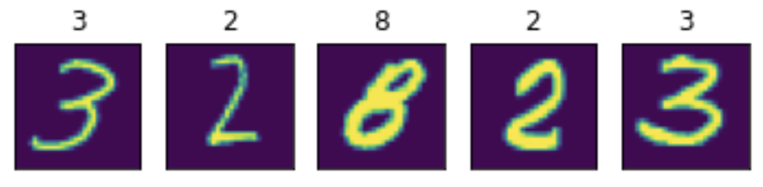
Google Colab is recommended for this tutorial. If you are running in colab, you should install the dependencies and download the dataset by running the following cell:
import subprocess

# Installation on Google Colab
try:
import google.colab
subprocess.run(['python', '-m', 'pip', 'install', 'skorch' , 'torch'])
except ImportError:
pass

from sklearn.datasets import fetch_openml
from sklearn.model_selection import train_test_split
import numpy as np
import matplotlib.pyplot as plt

Using SciKit-Learns fetch_openml to load MNIST data.
mnist = fetch_openml('mnist_784', as_frame=False, cache=False)

Each image of the MNIST dataset is encoded in a 784 dimensional vector, representing a 28 x 28 pixel image. Each pixel has a value between 0 and 255, corresponding to the grey-value of a pixel. The above featch_mldata method to load MNIST returns data and target as uint8 which we convert to float32 and int64 respectively.
X = mnist.data.astype('float32')
y = mnist.target.astype('int64')

To avoid big weights that deal with the pixel values from between [0, 255], we scale X down. A commonly used range is [0, 1].
X /= 255.0

Split the data.
X_train, X_test, y_train, y_test = train_test_split(X, y, test_size=0.25, random_state=42)

Plot data samples with labels to better understand the data.
def plot_example(X, y):
"""Plot the first 5 images and their labels in a row."""
for i, (img, y) in enumerate(zip(X[:5].reshape(5, 28, 28), y[:5])):
plt.subplot(151 + i)
plt.imshow(img)
plt.xticks([])
plt.yticks([])
plt.title(y)

plot_example(X_train, y_train)

The output demonstrates how the images and labels are aligned.

This next step builds a simple, fully connected neural network with one hidden layer. The input layer has 784 dimensions (28x28) hidden layer has 98 (= 784 / 8) and output layer 10 neurons, representing digits 0 - 9.

import torch
from torch import nn
import torch.nn.functional as F

device = 'cuda' if torch.cuda.is_available() else 'cpu'

mnist_dim = X.shape[1]
hidden_dim = int(mnist_dim/8)
output_dim = len(np.unique(mnist.target))

mnist_dim, hidden_dim, output_dim
# outputs: (784, 98, 10)

class ClassifierModule(nn.Module):
def __init__(
self,
input_dim=mnist_dim,
hidden_dim=hidden_dim,
output_dim=output_dim,
dropout=0.5,
):
super(ClassifierModule, self).__init__()
self.dropout = nn.Dropout(dropout)

self.hidden = nn.Linear(input_dim, hidden_dim)
self.output = nn.Linear(hidden_dim, output_dim)

def forward(self, X, **kwargs):
X = F.relu(self.hidden(X))
X = self.dropout(X)
X = F.softmax(self.output(X), dim=-1) # Create set of probabilities.
return X

skorch allows to use PyTorch's networks in the SciKit-Learn setting:
from skorch import NeuralNetClassifier

torch.manual_seed(0)

net = NeuralNetClassifier(
ClassifierModule,
max_epochs=20,
lr=0.1,
device=device,
)
net.fit(X_train, y_train);

Running the code will give the ouput:
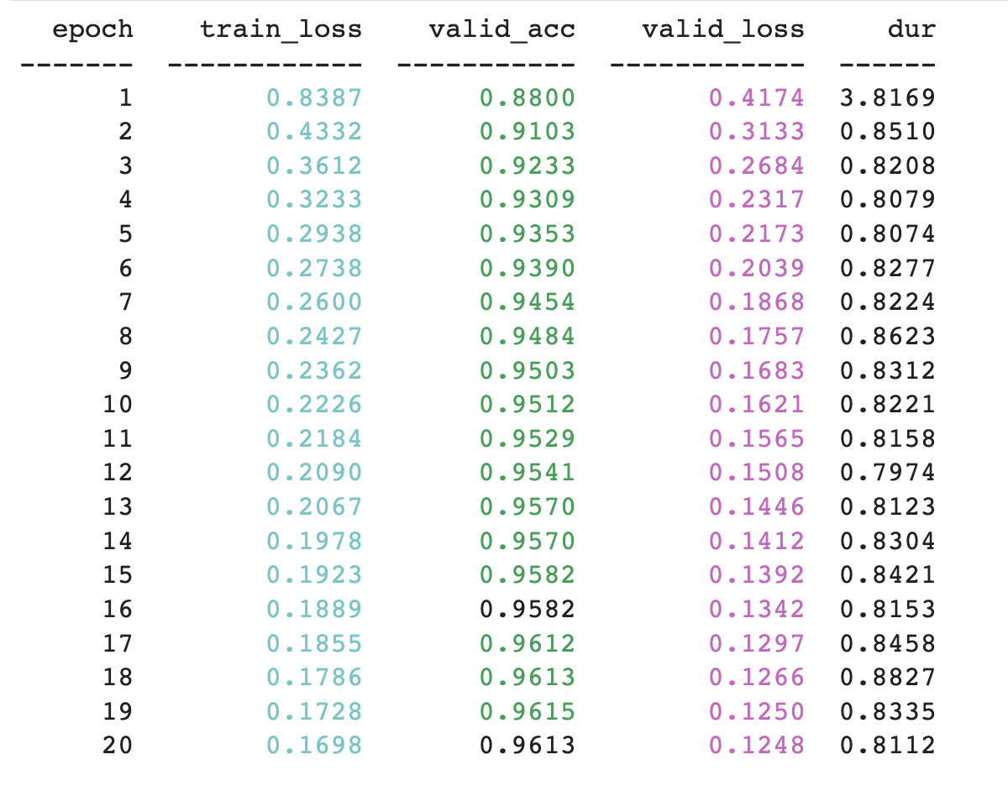
Lastly this code can be used to display the accouracy score.
from sklearn.metrics import accuracy_score
y_pred = net.predict(X_test)
accuracy_score(y_test, y_pred)

Exercise 9 (1 mark)
When defining our custom class to create our network in Example 3, what class is it inheriting from and how is this class significant?

Exercise 10 (1 mark)

Unlike Example 1which creates an instance of NeuralNetRegressor, Example 3 creates an instance of NeuralNetClassifier. Why is there a difference?

Exercise 11 (1 mark)
When observing the output from each epoch in Example 3 should we see the loss value increase or decrease over time?
Should we see the accuracy value increase or decrease over time?

Exercise 12 (3 marks)
There is not much to do here except to verify the code example is working. Run the code and add the code below with your name in it to get the mark. The sample output should look like the following but with your name:

Show your screenshot here:

